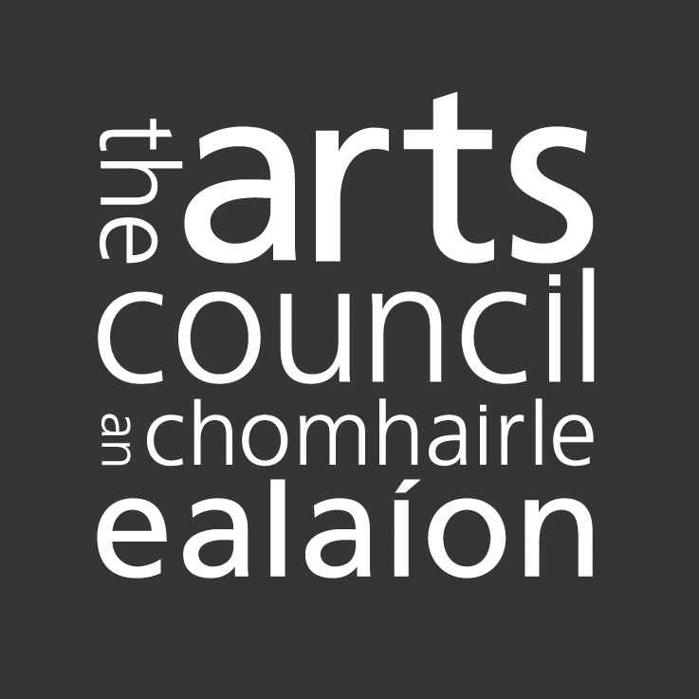

Creative Places Report Form

The Arts Council would like to know how the provision of the Creative Places award has been implemented from year to year.

Please take some time to complete this and return it to the Arts Council. An electronic version is available on our website (www.artscouncil.ie). Your information will help us to document and to improve the programme, and to evaluate their impact relative to our strategic priorities.

Please note the Declaration of Assurance section at the end of this Form. This must be signed by the applicant/s.

Part I

Contact details*

ARN

Application Number

Name

Address

Name of award
Date and amount of award

Application process*

How did you find out about the award?  - Website  - Word of Mouth  - Through the Arts Council  - Through the Media | - Artists’ representative/resource organisation  - Arts Council email newsletter  - Other (specify)
Was the application process reasonable? (i.e., forms, published criteria, timescale, efficiency)

If not, how could it be improved?

Were the Arts Council’s objectives in making the award clear?

Do you have any suggestions for improving the award?

PART II

Please describe the structural /organisational / governance progress you have made this year. Please provide as much quantitative and qualitative detail as possible, such as committee members, numbers of meetings, action plans, processes / personnel put in place etc.

Please describe the public engagement / participation progress you have / will have made this year, such as consultations, types of engagement, types of groups, different demographics, decisions made, actions taken etc.

Please describe the progress made on socially engaged arts practices / interventions / artists you have worked with. Please refer to developmental actions, outputs and outcomes

Please describe what actions you have taken to communicate, market, publicise or otherwise reach into the community you are working with.

Please describe any challenges you have encountered on any of the areas described above.

How can / did the Creative Places peer network support your development.

Any other comments?

Declaration of Assurance*

A declaration of assurance signed by the applicant and one other responsible person involved with the funded activity is required.

This is to certify that the Arts Council funding was used for the purpose for which it was granted and that any conditions attached to the funding were met.

I certify that the Arts Council funding was used for the purposes for which it was granted and that any conditions attached to the funding were met. Additionally, where I am in receipt of other sources of public funding I certify that there has been no duplication in the use of public funding for the same activity.

Name: Date:

Name: Date:
(Typed names are acceptable)

